[info@pro.com](mailto:info@pro.com)

[+977 9813639131](tel:+9779813639131)

•

•

•

•

•

•

•

•

•

•

Login / Register

* Home
* Courses
* News
* About
* Gallery
* Contact

# welcome to pro

### With our advance search feature you can now find the trips for you...

## popular courses

• free books for students

• • affordable fees

• • experienced teachers

* • free books for students

# why us?

Lorem Ipsum lorem ipsum Lorem Ipsum lorem ipsum Lorem Ipsum lorem ipsum Lorem Ipsum lorem ipsum Lorem Ipsum lorem ipsum Lorem Ipsum lorem ipsumLorem Ipsum lorem ipsum Lorem Ipsum lorem ipsum Lorem Ipsum lorem ipsum Lorem Ipsum lorem ipsum Lorem Ipsum lorem ipsum Lorem Ipsum lorem ipsumLorem Ipsum lorem ipsum Lorem Ipsum lorem ipsum Lorem Ipsum lorem ipsum Lorem Ipsum lorem ipsum Lorem Ipsum lorem ipsum Lorem Ipsum lorem ipsumLorem Ipsum lorem ipsum Lorem Ipsum lorem ipsum Lorem Ipsum lorem ipsum Lorem Ipsum lorem ipsum Lorem Ipsum lorem ipsum Lorem Ipsum lorem ipsumLorem Ipsum lorem ipsum Lorem Ipsum lorem ipsum Lorem Ipsum lorem ipsum Lorem Ipsum lorem ipsum Lorem Ipsum lorem ipsum Lorem Ipsum lorem ipsumLorem Ipsum lorem ipsum Lorem Ipsum lorem ipsum Lorem Ipsum lorem ipsum Lorem Ipsum lorem ipsum Lorem Ipsum lorem ipsum Lorem Ipsum lorem ipsum

read more

## gallery



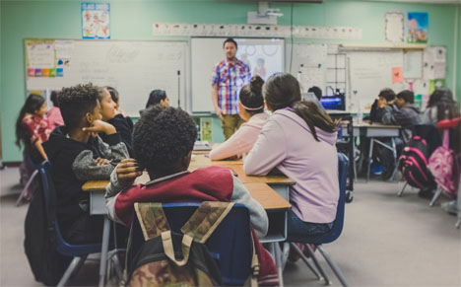



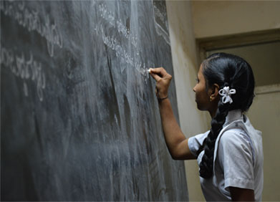



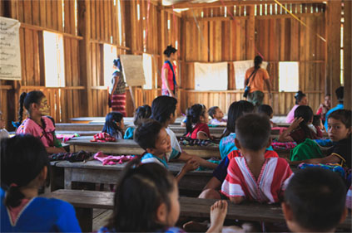

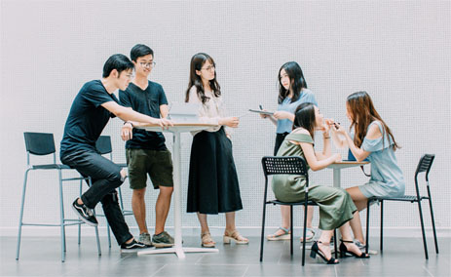



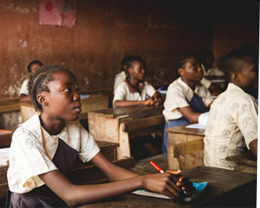

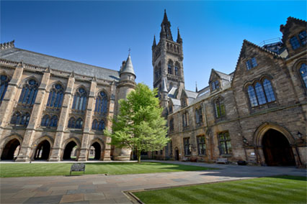



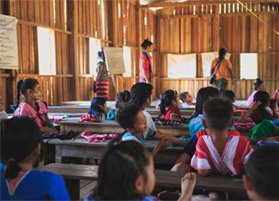

## upcomming events

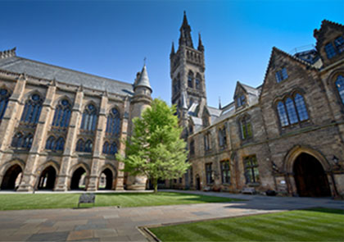

### Orientation Programme for new Students.

Orientation Programme for new sffs Students. Orientation Programme for new sffs Students. Orientation Programme for new sffs Students.

##### Dec 30,2018 | 11am

##### Hotel Malla, Lainchaur



### Orientation Programme for new Students.

Orientation Programme for new sffs Students. Orientation Programme for new sffs Students. Orientation Programme for new sffs Students.

##### Dec 30,2018 | 11am

##### Hotel Malla, Lainchaur

#### Get to Know

## what our customer say

## latest news

Any Queries? Ask us a question at

[+977 9813639131](tel:+9779813639131)

# about

Edulab is a great start for and education. Personnel or oganization to start the online business with 1 click

#### [+977 9813639131](tel:+9779813639131)

#### [info@pro.com](mailto:info@pro.com)

#### Gongabu, Kathmandu, Nepal

# links

* Teacher
* Courses
* Courses
* Courses
* Courses
* Courses

# recent courses

Ui/Ux Designing

### UI/UX Designer courses

$50 $40

Ui/Ux Designing

### UI/UX Designer courses

$50 $40

# quick contact



•

•

•

•

•

•

•

•